Version 2.0
PIVTR-D
A field manual for incident responders.
Habib Tora | September 2026
P  Preparation  readiness | I  Identification  alerting, detection, hunting | V  Verification  event, or incident? | T  Triage  rank against objectives | R  Response  scope, contain, eradicate, recover | D  Debrief  lessons learned, post-mortem, RCA

What this is, how to use it
Taken straight from Joshua Wright's excellent updated IR book, molded into a tldr guide for the common incident responder. The lifecycle, the decisions that go with it, and the paperwork nobody enjoys writing at two in the morning but everyone is glad of at the after-action review.
Find the phase you are in and go to its playbook in Section 3. Each one says what starts the phase, what finishes it, what record it leaves behind, and what to check along the way. Section 2 holds the decisions that should already have been made, so look there before improvising one at speed. Section 1 orients anyone who walks onto the bridge halfway through.
The checklists that go with these playbooks travel in a companion workbook, pivtr-d-checklists.xlsx, one tab per waypoint with columns for owner, date and notes. The record templates travel in pivtr-d-record-templates.docx. This document carries the model, the decisions and the reference tables.

1. The lifecycle
Read it left to right. Scope, contain, eradicate and recover repeat until scoping stops turning up new evidence. Decision makers sit behind the whole sequence rather than inside any one phase, because every gate needs them.
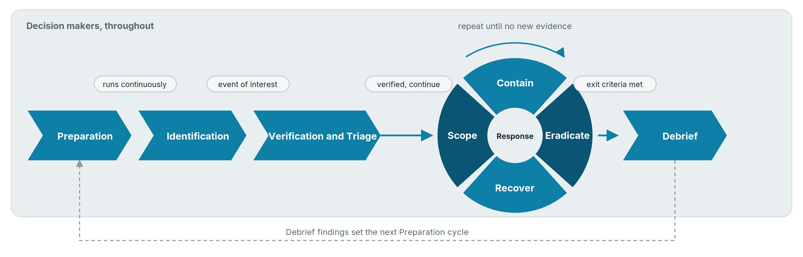
Each checkpoint sits above the junction it governs. Identification is drawn as continuous because it is. The dashed return path is the one most organizations never build.
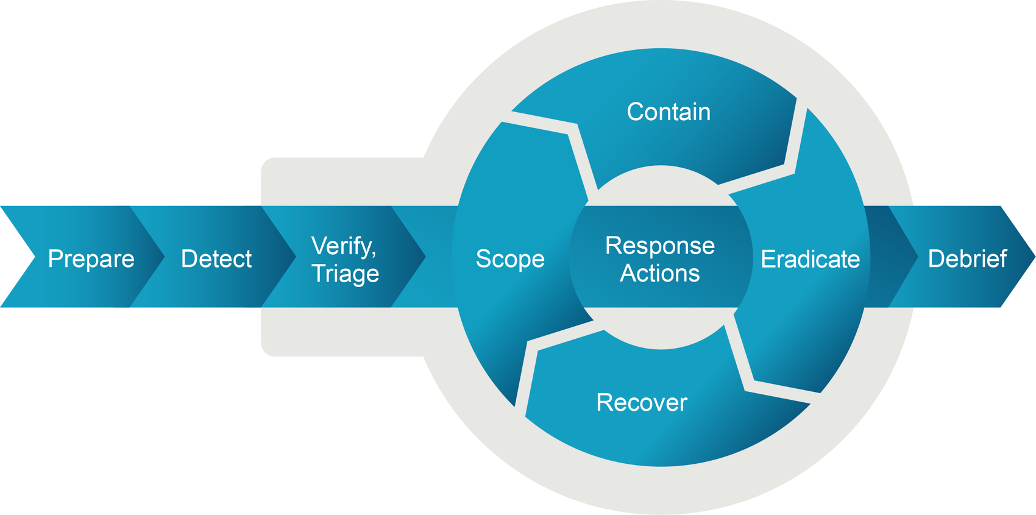
Figure 22. The source model. Detect becomes Identification so the letters match PICERL, and the four activities in the ring are grouped under Response. Nothing else changes.

Why the loop is there
Figure 23 draws four activities as steps: isolate and gather evidence under contain, analyze and remove persistence under eradicate, each running once and in order.
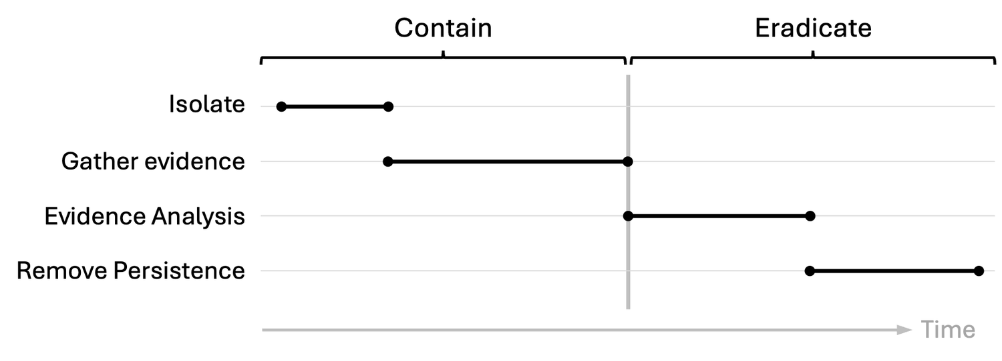
Figure 23. The stepped view.
Figure 24 draws the same four as they actually run. Isolation happens three times, evidence gathering starts and stops four times, and analysis runs underneath it all from early on. Plan for the second picture. Status reporting built on the first one contradicts itself by the third update.
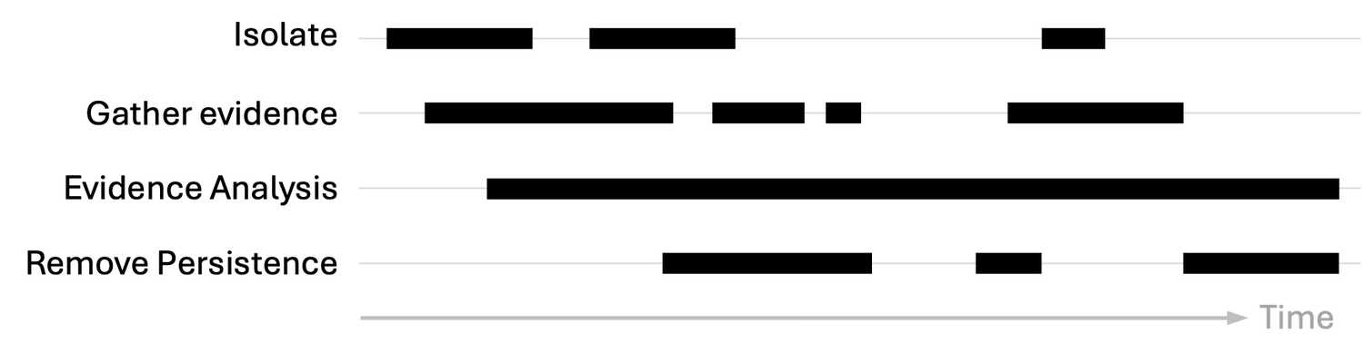
Figure 24. The same work, as it actually runs.
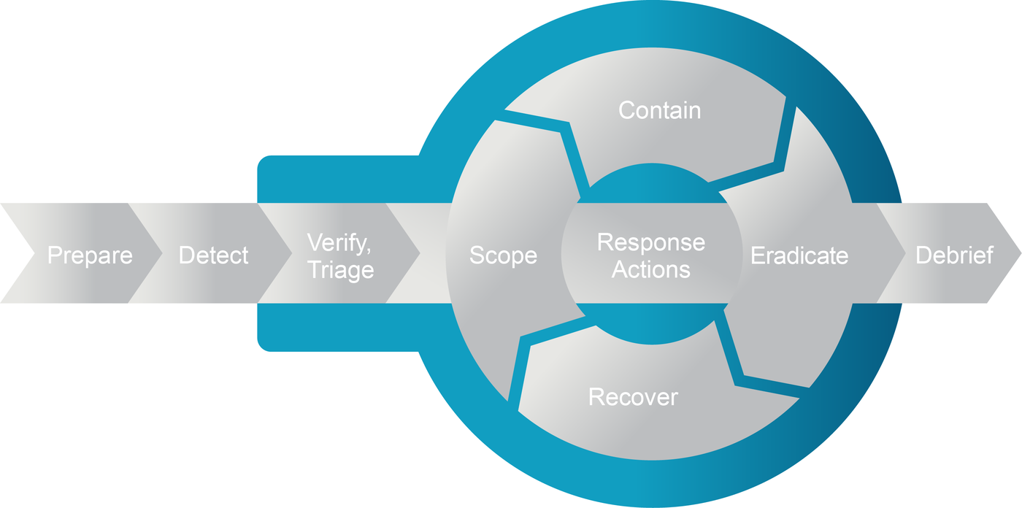
Figure 25. The highlight covers the whole model, not one stage of it.

Where the model came from
PICERL is the cycle most responders already know: preparation, identification, containment, eradication, recovery, lessons learned. All of it is here.
What PICERL leaves implicit is verification, triage and scope. They happen in every incident whether or not a model names them, and the unnamed activity is the one that gets skipped under pressure.
Scope, contain, eradicate and recover share the R because they repeat. Giving each its own letter would claim they run once each in order, which is the mistake this model exists to correct.
Letter | Phase | What it covers | In PICERL
P | Preparation | Readiness, authority, tooling, exercises, hunting | Preparation
I | Identification | Alerting, detection and hunting, all running continuously | Identification
V | Verification | Establish that the event is an incident requiring a response | Named here. Left implicit.
T | Triage | Prioritize the incident against organizational objectives | Named here. Left implicit.
R | Response | Scope, contain, eradicate and recover, repeating until scoping produces nothing new | Containment, Eradication, Recovery, plus scope named here
D | Debrief | Close the incident and convert it into changes | Lessons Learned

Verification and triage run together because both need the same conversation with decision makers. The hyphen marks where the incident ends and the closeout begins, and it stops the letters from being read as a word.

Start, work, finish, record
Activity | Starts when | Core work | Done when | Record produced
P. Preparation | No incident running | Policy, authority, playbooks, backups, tooling, exercises, hunting | Never closes. Reopened by every debrief. | Authority matrix, playbooks, asset and contact lists
I. Identification | Telemetry and reports flowing | Operate detections, work alerts, hunt on a cadence | An event of interest is raised | Alert or hunt finding with evidence references
V, T. Verification and triage | Event of interest raised | Confirm it requires a response, rank it against organizational objectives | Continue, stop, or defer, with a name against it | Incident record, triage brief
R. Response (scope) | Verified incident, one or more indicators | Derive indicators, enterprise hunt, progressive sweep, attack timeline | Breadth, systems involved and potential impact established | Scope findings, attack timeline
R. Response (contain) | Reach of the compromise clear enough to act | Stop attacker activity, preserve evidence by volatility | Three validation channels show activity stopped | Containment decision record
R. Response (eradicate) | Evidence collected and preserved | Short-form investigation, remove persistence, rotate credentials, patch | Rerunning the original enumeration comes back clean | Root cause, eradication log
R. Response (recover) | Eradication verified | Verification checks, validation testing, owner sign-off, restoration | Systems in production under enhanced monitoring | Pre-restoration sign-off, owner acceptance
D. Debrief | Loop exited and signed | Close temporary assets, consolidate records, metrics, after-action review | Improvement plan issued with owners and dates | Incident report, metrics, improvement register

2. Decide these before the incident
Settle these in advance and refer to them during the response. Working out who can authorize taking production offline while the file shares are encrypting spends the only time that matters on a phone tree.

Who authorizes what
Structure from p. 97. The role names and containment tiers are placeholders. Replace them with yours before anyone relies on this.
Decision | Authority | Delegate | Record required
Declare an incident | Incident commander | Senior analyst on duty | Ticket with declaration time and rationale
Isolate an endpoint | SOC or IR analyst | None needed | Containment decision record
Isolate a server or service | Service owner with incident commander | Incident commander alone if the owner is unreachable inside the response window | Containment decision record with impact assessment
Shut down production, or anything touching regulated services | Named executive | CISO after hours, ratified next business day | Containment decision record plus executive approval
Expand scope to other business units | Incident commander, CISO notified | None | Scope expansion entry with the trigger
Exit the loop, technical closure | Incident commander on eradication validation | Senior analyst with written approval | Signed technical closure record
Accept residual risk | CISO or named risk owner | Board-level executive for significant incidents | Signed risk acceptance naming the risks
Notify a regulator | Legal counsel with the CISO | General counsel | Decision log with timeline and regulator named
Speak to media or the public | Communications lead with legal sign-off | CEO for material incidents | Approved statement under version control
Pay a ransom | Written position agreed in advance, then named executive with counsel | None | Decision log naming counsel and carrier consulted

When containment cannot wait
Table 17, p. 227. Map each trigger to an approved action during preparation.
Trigger | Indicators | Approved action
Active destruction | Encryption spreading across shares, event logs wiped, database tables dropped | Isolate immediately
Exfiltration | Large transfers to cloud storage, bulk queries against personal data, archives sent to external sites | Contain urgently to cap exposure
Safety or critical systems | ICS, medical devices, payment processing, other safety-critical infrastructure | Act immediately and accept the loss of intelligence
Regulatory clock | Data or services under HIPAA, PCI DSS, GDPR, NIS2, DORA, CRA, or a local equivalent | Contain rapidly to limit affected records

Which containment posture
Table 16, p. 223. Deceptive containment is drawn from the same chapter's step-by-step reference.
Situation | Posture
Destruction or ransomware underway | Active, required
Regulated data with a compliance clock | Active, required
Safety-critical or high-availability system at risk | Active, required
Attacker shows awareness of defenders | Active, strongly favored
Short dwell time, limited monitoring maturity | Active, strongly favored
Extended dwell time, mature monitoring | Adaptive, strongly favored
Unknown scope, uncertain sophistication | Adaptive, preferred
Commodity malware on a low-value asset | Passive, possible
Controlled deception environment | Passive or deceptive, possible

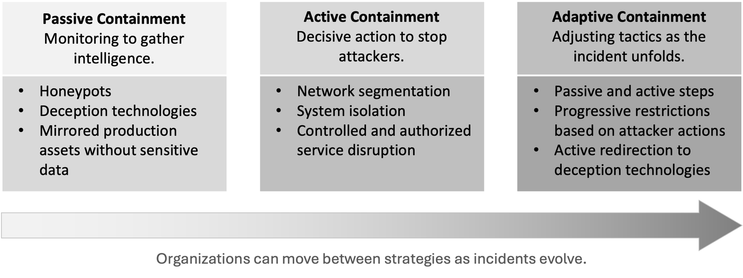
Figure 75. The arrow matters. Posture changes within a single incident as understanding improves.

Risk levels and what they trigger
Levels from p. 171. The trigger column is mine, and the thresholds should be yours.
Level | Meaning | What it triggers
Low | Minor anomaly, minimal impact | Analyst handles it, logged only
Medium | Worth investigating, operations unaffected | Incident commander informed, daily update
High | Confirmed incident affecting operations or data integrity | Team activated, decision makers briefed, update cadence set
Critical | Major incident | Executive escalation, immediate containment authority granted, counsel engaged

3. Phase playbooks, P to D

P. Preparation
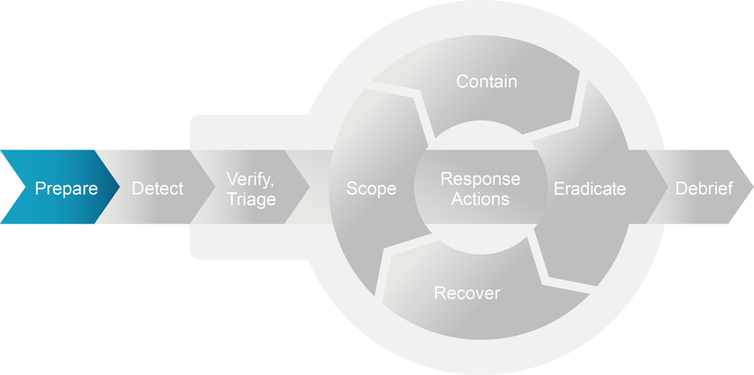
Figure 29
Starts when  No incident running. This is the default state. | Done when  Never closes. Every debrief reopens it with named owners.

Most of the team's hours belong here, and the work is hardest to fund when it is working, because nothing has gone wrong. Measurements make the case where a maturity model cannot: time to detect, how fast the last drill contained, what the last tabletop exposed.
Capability is what gets used. An intelligence feed nobody queries, a console nobody opens, and a playbook last edited by someone who has since left do not become useful when the incident starts.

I. Identification
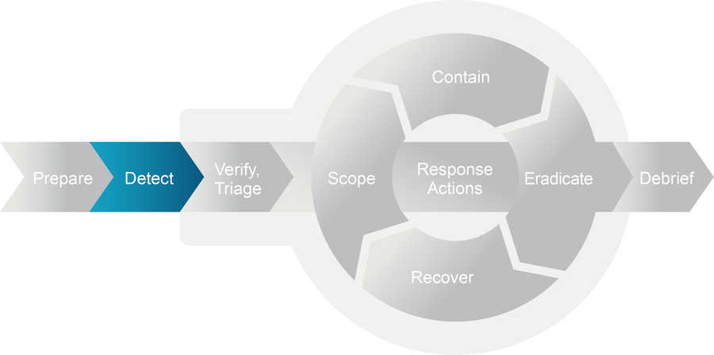
Figure 50
Starts when  Telemetry and reports flowing. Runs continuously. | Done when  An event of interest raised with evidence references attached.

Identification covers alerting, detection and hunting. Alerting is what reaches you, detection is the engineered logic behind it, and hunting is what finds whatever neither one caught.
Only hunting moves time to detect. Alerting and detection both mean something else found it first, and you inherit whatever dwell time that cost.
Layer the methods, and map detection logic to MITRE ATT&CK so the rules survive a change of tooling. Final classification stays with an analyst, because no model knows about the migration that started on Monday.
Method | Strong on | Weak on
Signature | Known malware and patterns at machine speed, few false positives | New variants, zero days, and any attacker who has read the signature
Behavioral | Mass encryption, off-hours access, living off the land, insider misuse | Depends on a tuned baseline. One company-wide baseline hides anomalies.
Machine learning | Subtle patterns, triage and prioritization | No organizational context, so the final call stays with a person
Hybrid | Layered coverage that survives tool changes | Cost and complexity of operating several platforms together

Spend hunting hours above the automation line, on the artifacts an adversary cannot cheaply swap out. Hashes and addresses burn on contact, and automation already covers them at machine speed.
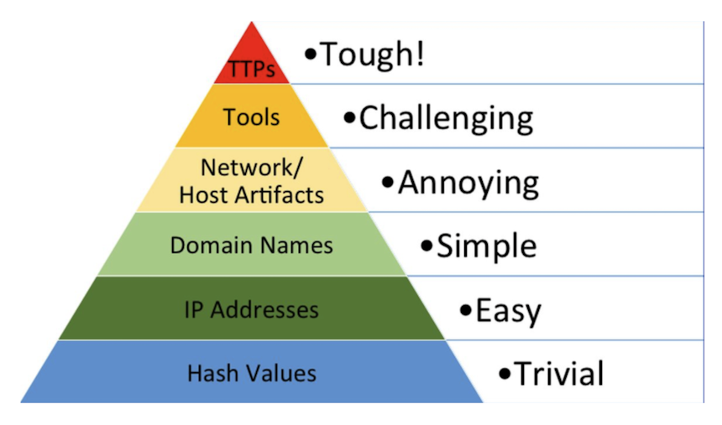
Figure 52. The Pyramid of Pain, David Bianco, 2013.
Layer | Cost to change | Who chases it
TTPs | Tough | Analysts. Methods the adversary cannot abandon.
Tools | Challenging | Analysts, with detections built on tool behavior
Network and host artifacts | Annoying | Analysts, on beaconing, process chains, lateral movement
Domain names | Simple | Automation, with analysts pivoting from the hits
IP addresses | Easy | Automation
Hash values | Trivial | Automation. High confidence, short shelf life.

Watch out
• A single baseline averaged across business units defines normal too broadly for anomalies to surface. Scope baselines per business unit or per function.
• Hunt from a catalog, with a hypothesis, a named data source, and a cadence. Findings from unstructured hunting are hard to repeat and harder to defend.

V and T. Verification and triage
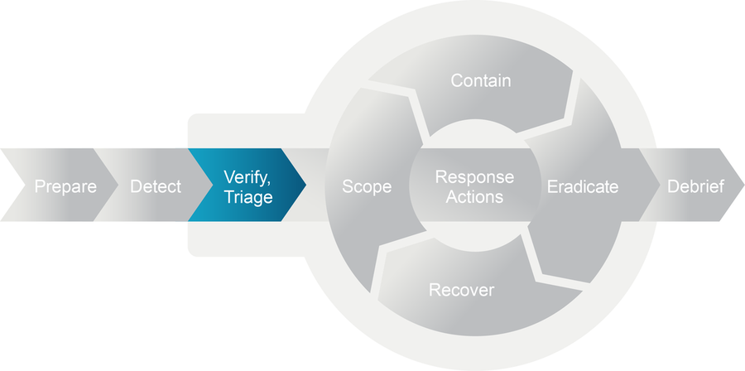
Figure 57
Starts when  An event of interest with evidence references. | Done when  Continue, stop, or defer, with a name and a time against it.

Verification establishes that the observed event is an incident, and one that requires a response. Triage ranks it against organizational objectives so the team works the most important incident first, which matters most when the impact is broad.
Verify before engaging the wider team. A declared incident has a cost of its own, pulling people off other work and slowing the systems under investigation, and that cost is worth paying only for real ones.
They run concurrently because both need the same insight and coordination from decision makers, and the outcome of both is the right resources on the right incident.
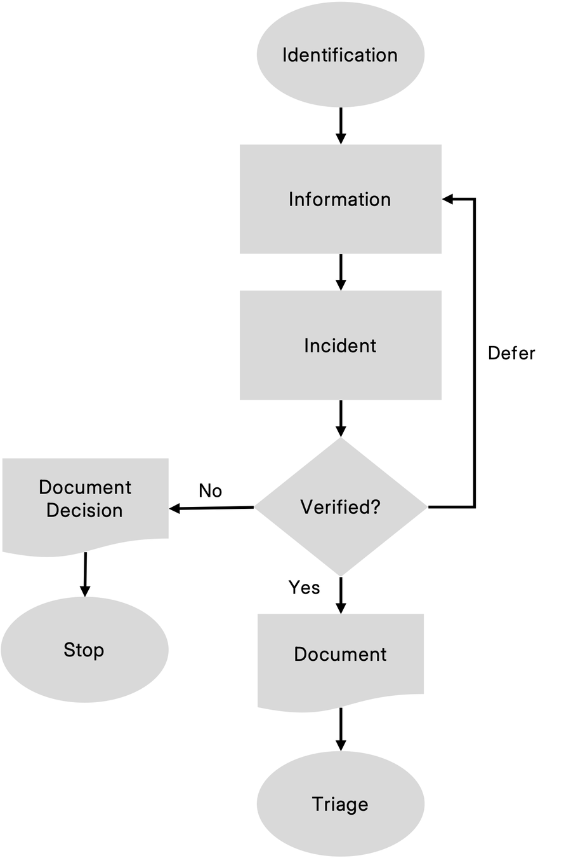
Figure 58. Deferring is a real outcome, and recording it is what keeps it from becoming a dropped ticket.
Outcome | Use when | Then
Continue | Real, and it warrants a response | Escalate, engage the team and decision makers, triage
Stop | Not real | Close it and document why, for the next analyst who sees the same thing
Defer | Available information cannot settle it | Request more from the reporter or other sources, then decide again

Watch out
• Documentation written after the fact is unreliable, and exact commands and timestamps are the first things to go. Open the record at verification and add to it as the response proceeds.

R. Response (scope)
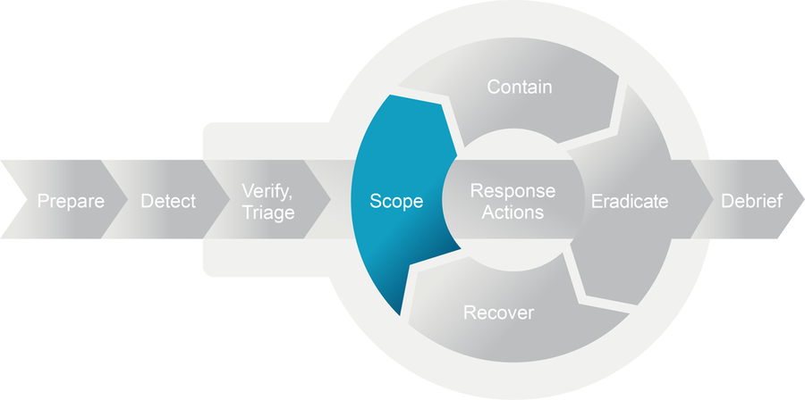
Figure 69
Starts when  Verified incident with at least one indicator. | Done when  Systems, accounts, and data enumerated, with visibility gaps named.

Scope establishes the breadth of the incident, the systems involved, and the potential impact on the organization. It starts from what identification and verification produced, works out the attacker's TTPs, derives indicators from them, and uses those indicators to find every system in scope.
Do it before cleaning anything. Cleaning only the systems you already know about leaves the attacker the rest, which is how the same incident gets declared twice in a quarter.
Scope owns the attack timeline. Eradication annotates it, the debrief finalizes it, nobody else redraws it.
Phase | Targets | Sources
Critical assets first | Domain controllers, file servers, databases, anything holding sensitive data, regardless of where the first indicator appeared | SIEM, EDR, authenticated scans
Lateral expansion | Same segment, systems authenticated to by compromised accounts, systems sharing administrative credentials | Authentication logs, EDR, network flow
Environmental sweep | Everything remaining. Days or weeks at scale. | EDR, inventory tools, scripted checks, compromise assessment tooling

Watch out
• In OT the visibility gap is the normal condition. Controllers do not log centrally, agents cannot be installed, and the maintenance window is next quarter. Plan on network flow as the primary evidence source, and write that into the response plan before it is needed.

R. Response (contain)
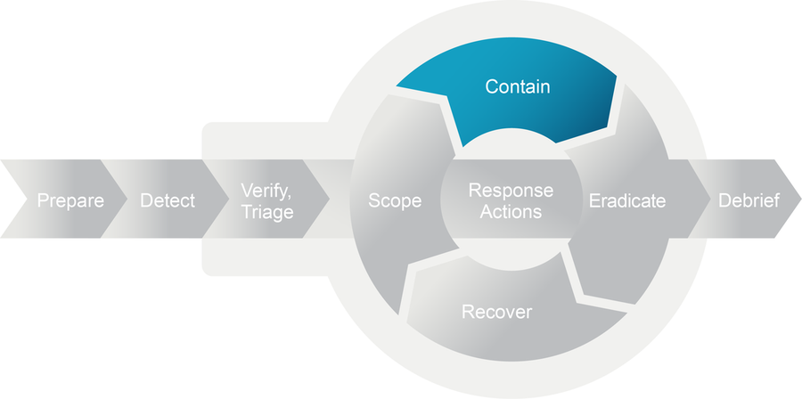
Figure 74
Starts when  Scope clear enough to act, posture chosen, authority in hand. | Done when  Network, process, and log channels all show attacker activity stopped.

Containment stops the attacker and preserves the evidence.
Cut the specific paths the attacker is using. Pulling the host stopped being a general strategy once estates went distributed. A compromised web server isolated from internal systems while it keeps serving the internet is contained, and the site is still up.
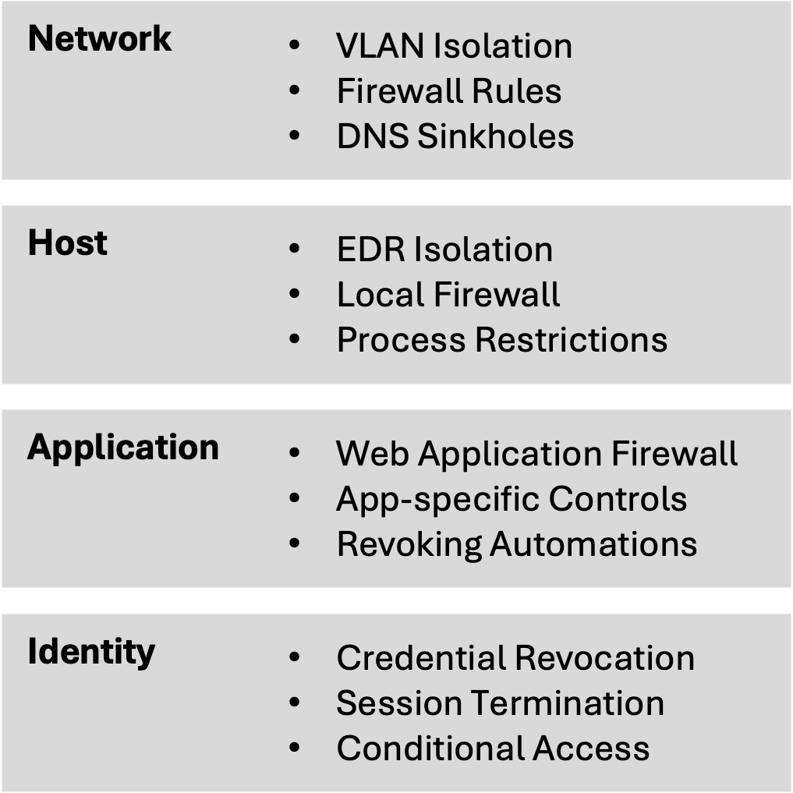
Figure 77. Containment layers.
Layer | Use it for
Network | Broad, fast control over many systems at once
Host | Precision on a known-compromised endpoint
Application | Attacker tooling that network controls do not see
Identity | SaaS and cloud paths, where it is frequently the only layer that reaches

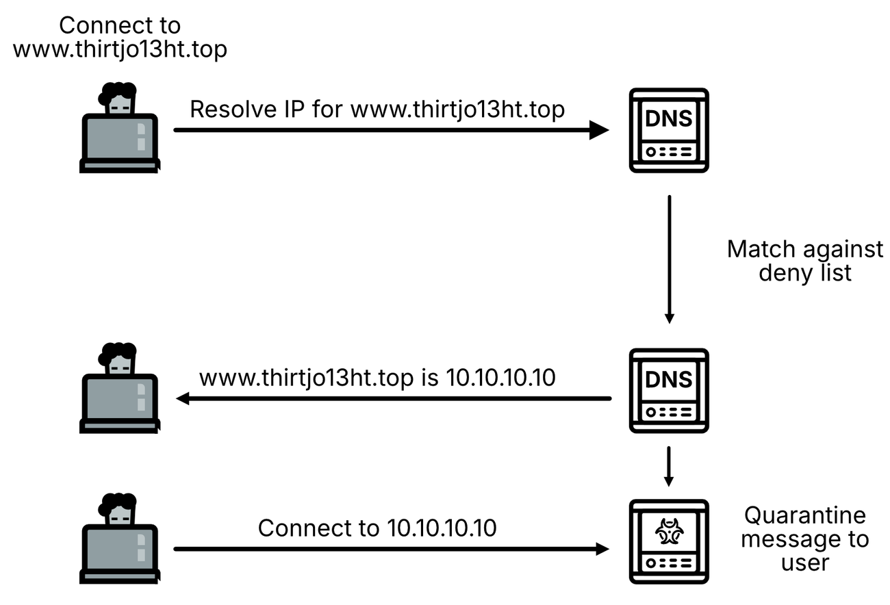
Figure 79. DNS sinkholing redirects command and control traffic to a controlled destination.

The best-known sinkhole in the field
Reporting by WIRED, TechCrunch and the Associated Press; sinkhole data published by Kryptos Logic
WannaCry, 12 May 2017. The worm was spreading across Europe and the NHS was turning patients away. Marcus Hutchins, working for Kryptos Logic from England, found an unregistered domain inside a WannaCry sample and bought it on Namecheap for $10.69, intending to sinkhole the traffic and count infected hosts. The malware checked whether that domain resolved before encrypting anything and halted when it did. Another researcher reverse-engineered the check and confirmed the behavior. Spread of that variant stopped the same afternoon.
The technique was ordinary DNS sinkholing, the same mechanism in Figure 79, applied at internet scale by accident. Hutchins told the Associated Press at the time that he was not a hero and was just doing his part to stop botnets.
It eradicated nothing. Variants with different killswitch domains appeared within days, unpatched hosts were still reaching the sinkhole years later, and Boeing, Honda, Connecticut state agencies and Victoria state police all reported infections during 2018. A sinkhole buys time to patch. The patching still has to happen.
Watch out
• Human-operated ransomware groups have accelerated encryption after detecting defensive action, and watchdog processes respawn malware or trigger destructive payloads. Move quietly until the adversary is understood.
• Sequential isolation signals the response and gives the adversary time to escalate. Execute simultaneously across the network, endpoint, identity, and application teams.
• Write the rollback procedure before changing firewall rules or network topology. It will be requested at the worst possible time.

R. Response (eradicate)
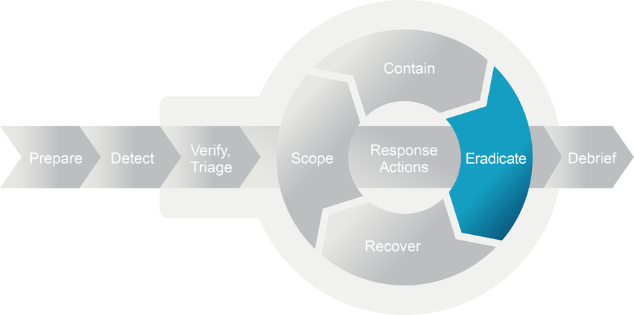
Figure 91
Starts when  Evidence collected and preserved. | Done when  Rerunning the enumeration that found the problem comes back clean.

Contained systems cost money every hour they stay down, and reading disk and memory properly takes days or weeks, so the investigation runs on two tracks at once. Short-form work answers enough to act on. Long-form work carries on for the full TTPs, regulatory reporting, and anything that ends up in front of a court.
The short-form track establishes what the attacker did, how they got in, where else they might be, and what has to go so they cannot come back the same way. The output is rough by design. The source book's tech editor calls it a dirty kebab, which is a fair description of a legitimate deliverable.
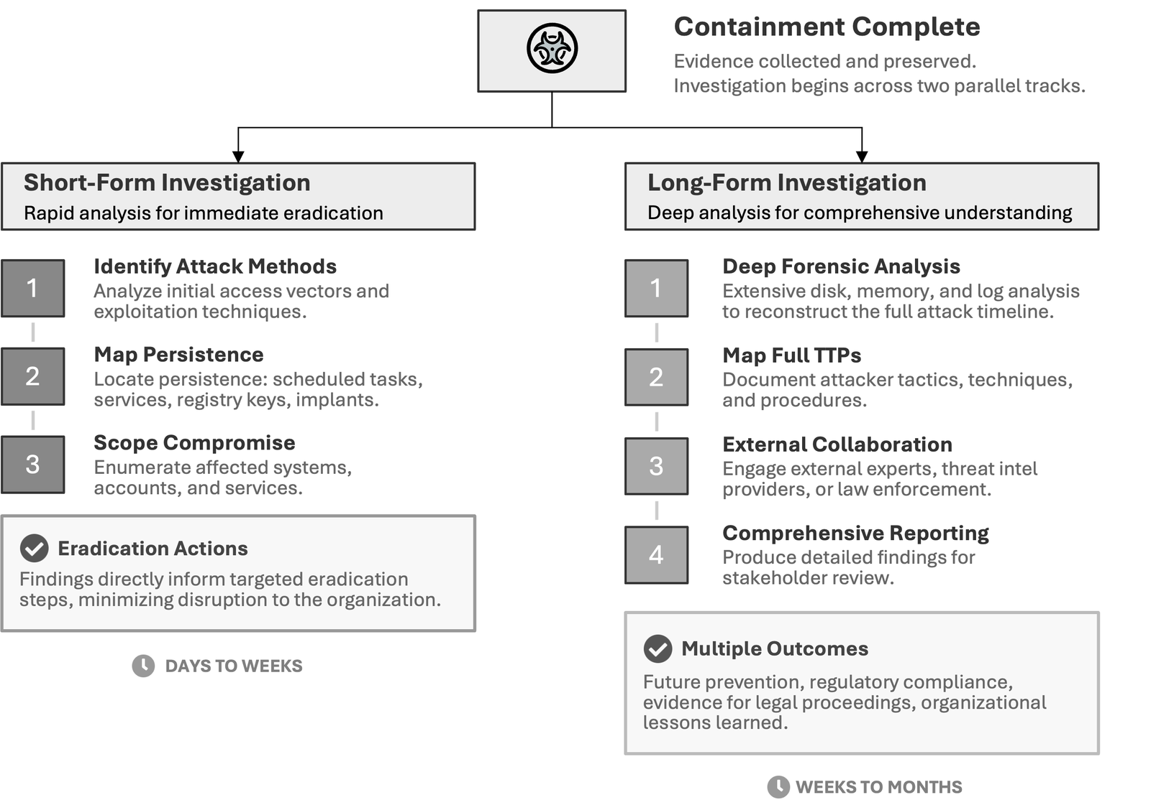
Figure 92. Agree the scope of both tracks with decision makers, in writing.
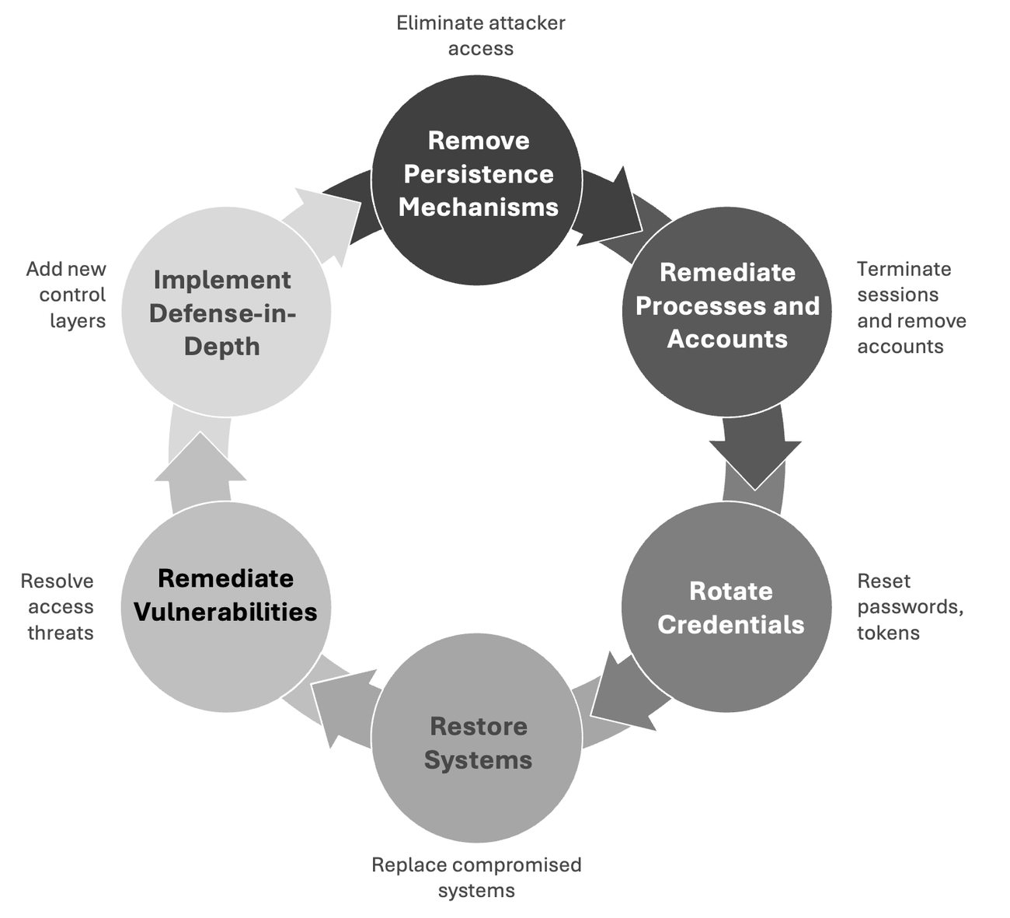
Figure 108. The six categories of removal work.

Credential reset phasing
Structure from Table 31, p. 369. The windows come from the book's worked example and need replacing with yours.
Phase | Scope | Window in the example
1 | KRBTGT, reset twice, then Tier 0 accounts | Friday 11 PM to Saturday 3 AM, scheduled maintenance
2 | Tier 1 accounts and critical service accounts | Saturday 6 AM to noon, reduced trading hours
3 | Tier 2 accounts and remaining service accounts | Saturday 2 PM to Sunday 6 PM

Watch out
• The double KRBTGT reset depends on the interval between resets. Reset once, confirm replication across all domain controllers, then wait longer than the maximum ticket lifetime before the second reset so any existing golden ticket expires. The example allows ten hours.
• Track every service account with its dependent applications and owner, and have the application team test the credential update in staging before the window. Expect the backup service account to be the one that breaks.
• Keep emergency access available. Issue short-validity temporary accounts to on-call staff whose credentials are being reset.

R. Response (recover)
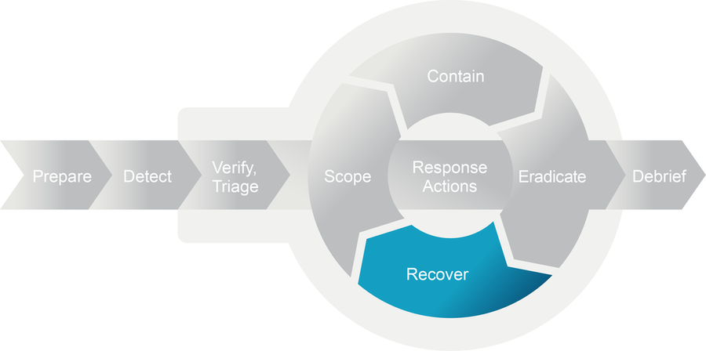
Figure 122
Starts when  Eradication verified. | Done when  Systems in production under enhanced monitoring, owner sign-off on file.

Work the checks in order before anything returns to production. The indicator scan comes last, because scanning a half-patched box tells you nothing about the build that ships.

D. Debrief
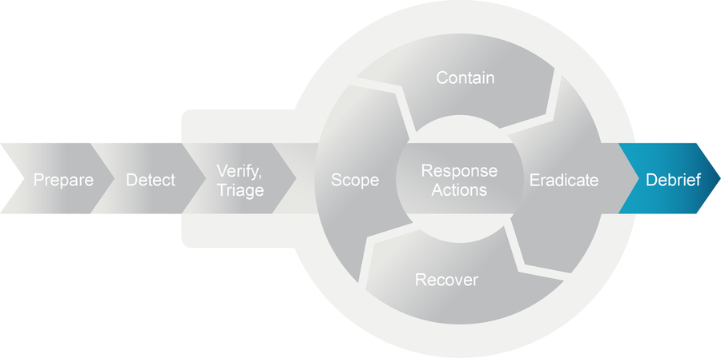
Figure 131
Starts when  Loop exited, technical closure and risk acceptance both signed. | Done when  Improvement plan issued with named owners and milestone dates.

This is the phase other traditions call lessons learned, the post-mortem, or root cause analysis. Same activity, whichever name your organization uses.
Closing the incident and turning it into changes are one activity. Funding stays available for about a month after closure, while the board still remembers being frightened, so arrive with the improvement plan already costed and an owner and a date on every line.

Running the response loop
Put the same question to every new fact: does this change scope, containment, eradication or recovery? If it does, the team is on another pass. Say so on the bridge, because silence reads as progress and stakeholders start planning the all-clear.
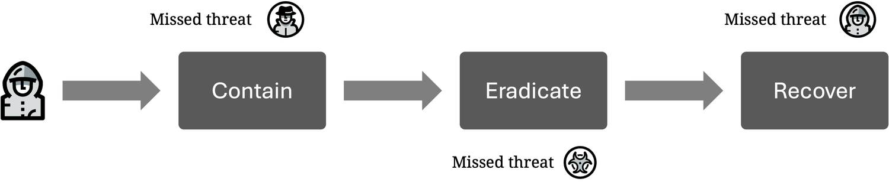
Figure 67. Three threats pass through unnoticed.
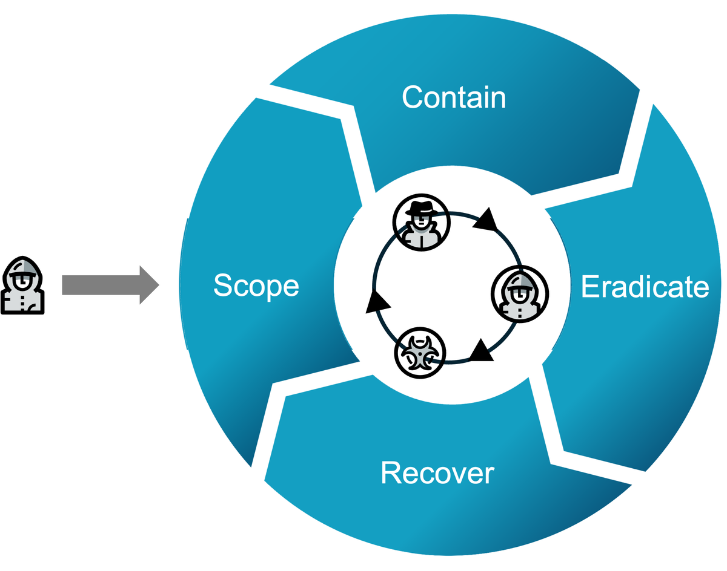
Figure 68. The same three threats, caught across successive passes.
A straight line through contain, eradicate and recover misses whatever only becomes visible once the evidence has been read. That is the difference the two figures are drawing.
Trigger | Looks like | Next move
New indicators | A PowerShell script in a registry key, traffic to unknown C2 | Back to scoping with the new indicator
Scope expansion | A known compromised service account also active in a regulated system | Another scoping pass, with new stakeholders and new obligations
Incomplete eradication | A system that looked clean shows reinfection | Hunt the missed persistence or the unidentified access vector
Analysis revelations | Memory forensics finds a second malware family | Rescope, then revisit containment and eradication
Business change | A new obligation or a shift in priorities | Re-triage and reset the plan with decision makers

Watch out
• Rotate people and schedule rest. Fatigue accumulates across iterations and rarely appears in any report.
• Documentation has to survive shift handover, or incoming analysts repeat work or skip it.
• Name the person who authorizes the exit. An attributed written decision holds up if the incident is reopened or reviewed, and people commit more carefully when their name is on it.

4. Templates
Each record copies to the clipboard.

5. Metrics
Definitions from pp. 445 to 446. Iteration count is mine.
Metric | Measured from | This incident
Mean time to detect | Incident start to detection
Mean time to respond | Detection to resolution
Time to containment | Detection to attacker activity stopped
Time to eradication | Containment to persistence removal complete
Time to full recovery | Detection to all systems restored
Total lifecycle | Initial compromise to verified resolution
Systems affected | Servers, workstations, cloud resources
Accounts affected | Compromised or requiring reset
Data exposure | Record count, classification, regulatory categories
Business impact | Disruption duration, revenue effect
Effort and cost | Personnel hours, external services, tooling, any ransom paid
Iterations | Passes through the response actions loop

Record these the same way every time. Comparison across incidents is what shows whether the team is improving, and the numbers are what fund the improvement plan. Iteration count is here because it shows whether scoping caught things early or late, and nothing else in the set does.

6. Attribution
The model is adapted from Dynamic Incident Response by Joshua Wright, published by the SANS Institute in 2026 under CC BY 4.0. The numbered figures are reproduced from it. Changes were made.

